The increasing complexity has driven desire to find ways to better manage this complexity
Desire to create efficient portable programs
Languages evolve to adapt to changes in the environment and to implement advances in the art of programming
Two types of information transmitted over the internet
- Passive Information
- Dynamic Information
All Programs consist of Code and data

Program Construction
Process- oriented model
- Linear steps
- Code acting on data
Object oriented programming

Three OOP Principles
- Encapsulation
- Inheritance
- Polymorphism
  - One interface multiple methods
These all work together

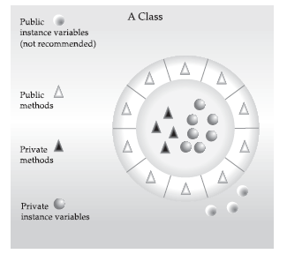

SOLID
Single Responsibility
- A class should have one responsibility
- Benefits
  - Testing – A class with one responsibility will have far fewer test cases
  - Lower coupling – Less functionality in a single class will have fewer dependencies
  - Organization – Smaller, well-organized classes are easier to search than monolithic ones

Open for Extension, Closed for Modification
Liskov Substitution

